Chapter 3
CHUDEN
HASEGAWA EISHIN RYU
(Tachihiza)
(Middle Tradition, Raised Knee Forms)

Introductory comments

Regarding Tachihiza (Raised Knee)

There are 10 Chuden forms. With the exception of Nukiuchi, all of them begin in tachihiza.

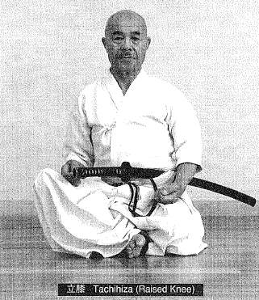

How to Sit in Tachihiza

After performing a seated bow, stand up.

1. Pick up your sword, placing your left thumb on the tsuba.

2. Leaning your upper body forward, bend your knees, opening them to the left and the right.

3. With your right hand, but the hakama hem from the inside to the outside.

4. At the same time, slide your left foot back one step, kneeling the left knee on the floor.

5. Extend your toes (flatten your foot) and sit with your left leg crossed.

6. Sit on your left leg so that the left heel touches your anus.

7. At this time, use your right hand to bat the right hakama hem to the outside so as not to get your foot tangled in it.

8. At the same time, slide your right foot slightly forward so that the right heel comes in front of the left ankle and drop your right knee diagonally to the side.

9. The outer edge of the right foot should rest on the floor with the inner edge slightly floating.

10. Take care not to have your right toes sticking out in front ol' your left knee.

11. Sit with your upper body straight; lean neither to the right not left, nor to the front nor back. Concentrate power in your lower abdomen and relax your shoulders.
12. Rest both hands naturally on your thighs with the fingers turned up and curled inward slightly (loose fists).

13. Rest both elbows lightly at your sides, without stretching them.

14. When assuming tatehiza, position your left leg first. When rising from tatehiza, start with your right leg.

Characteristics of the Chuden Forms

The following ten forms compose the Chuden:

- Ipponme (一本目) Yokogumo (横雲)
Form #1 “Cloud Bank”
- Nihonme (二本目) Tora Issoku (虎一足)
Form #2 "Tiger's First Step"
- Sanbonme (三本目) lnazuma (稲妻)
Form #3 "Lightning Flash"
- Yonhonme (四本目) Ukigumo (浮雲)
Form #4 "Drifting Cloud"
- Gohonme (五本目) Yamaoroshi (颪)
Form #5 "Mountain Wind"
- Ropponme (六本目) lwanami (岩浪)
Form #6 "Waves Against the Cliff"
- Nanahonme (七本目) Urokogaeshi (鱗返)
Form #7 "Turning the Scales"
- Happonme (八本目) Namigaeshi (浪返)
Form #8 "Returning Wave"
- Kyuhonme (九本目) Takiotoshi (滝落)
Form #9 "Down the Waterfall"
- Jupponme (十本目) Nukiuchi (抜打) Makko
Form #10 "Draw & Cut" “Head on"

While the Shoden forms create the proper distance to the enemy by stepping forward, many of the Chuden forms step back and create this distance by drawing the saya off of the sword. That is to say, most of the Forms operate on the premise that the enemy is sitting very close to you. This is the major characteristic of the Chuden forms.

All of the chiburi in Chuden are of the same type as described for the first chiburi in the Omori style form, lnyoshintai. While straightening the right knee, you simultaneously release your left hand front the tsuka and place it at your left hip, opening your right hand (which is gripping the sword) horizontally to the right.

In Shoden, noto is commenced by placing the spine of the sword against the near the base of the tsuba; in Chuden. The spine of the sword is placed against the koiguchi near its center. In Okuden, the spine of the sword is placed on the koiguchi near the kensen or the monouchi and noto is performed rapidly.

In our style, both Shoden and Chuden use the horizontal noto, just like the Japanese character for "one" (一).

Ipponme Yokogumo Form #1 “Cloud Bank”

Intent:

- You perform nukitsuke (draw & cut) with the same intent as you did in Shohatsuto; however, instead of Stepping your right foot forward, you step your left foot backward.

- In instances where you have plenty of room you would, of course, step the right foot forward; however, the basic element in this form is to draw your left foot back.

Execution:

1. Sit in tatchiza (raised knee position), facing the front.

2. Place both hands on the sword.

- As you flex the left toes back to rise up on them and slide the left foot backward
- Execute nukitsuke, targeting the enemy's temple. (1)

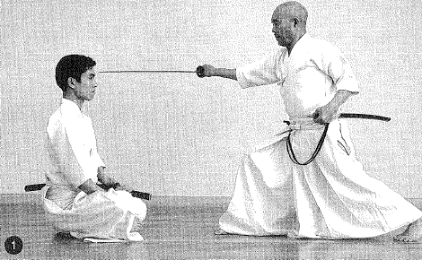

Take care not to raise the left knee far above the floor. Keep your hips low.

3. Slide your left knee up to your right heel.

- Raise your sword in furikamuri (raising the sword overhead)
- Perform kirioroshi (vertical downward cut) directly through the center of the enemy

4. Perform an Eishin style chiburi.
5. Perform noto.

Having inserted 1/3 of the blade and while maintaining zanshin, keep your right heel straight ahead, slide it back to your left heel. In other words, end noto with your left knee down in a crouching posture. Having finished noto, your heels should be about 15 cm apart and your buttocks should rest lightly on both heels.

All of the following Chuden chiburi and noto should be performed in this style (as illustrated in pictures 3-4 in description of the Form #5 Shoden).

Nihonme Tora Issoku Form #2 "Tiger's First Step"

Intent:

An enemy advances directly from the from and cuts at your right leg. As in Shoden form #12, Inyoshintai kaewaza, you parry the blow; then perform kirioroshi (vertical downward cut) as the enemy attempts to flee.

Execution:

1. Sit in tachihiza, facing the front. The enemy sits about 80 cm away. (1)

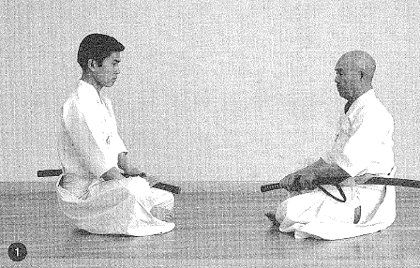

2. As the enemy attempts to cut your right leg, grip your sword with your right arm in a right angle position. (2)

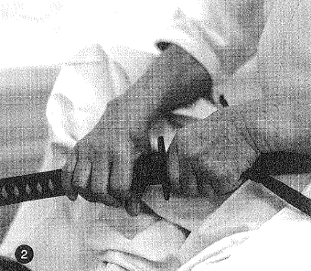

- Rapidly execute batto.

- Parry the enemy's sword with the shinogi in order to protect your shin . (3)

While doing this, turn your hips slightly to the left and use your left hand to pull back. (4)

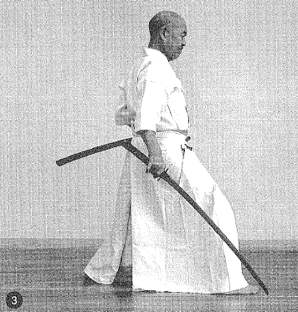

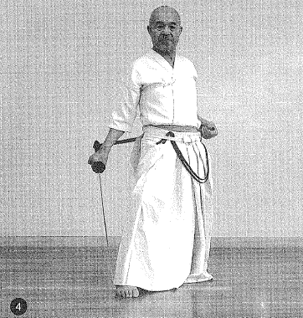

3. Move forward by sliding your left knee to your right heel in it kneeling slide. Perform furikamuri.

- Step the right foot out one step into a right angle position

- Simultaneously cut the enemy through with kirioroshi.

4. Perform chiburi and noto, as performed in form #1.

Performing a rapid batto means that in the split second the last 9 cm of the kissaki leaves the koiguchi, you powerfully and quickly draw and strike as if to snap the sword out.

Sanbonme lnazuma Form #3 "Lightning Flash"

Intent:

- An enemy to your front advances from jodan with kirioroshi.

- You cut the side of the enemy's wrist (forearm); kneel, and fell the enemy with kirioroshi.

Execution:

1. Sit in tachihiza facing the front.

2. The enemy attempts to cut you down with kirioroshi, so you place both hands on your sword.

- Raising up your right knee, stand up in chugoshi

- Draw your left foot back one step

- Slightly twist your hips to the left (maintatining chugoshi)

- Draw and cut the side of your enemy's wrist (illustration 1). Make sure you fully utilize your drawing hand (left hand) as you draw

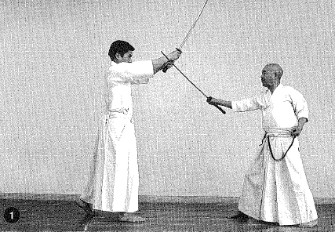

- When rising up from below to cut your enemy's right wrist, the blade of your sword should be level or angled slightly upwards (diagonally)

- You should not fix your eyes on the kensen but straight ahead at eye level.

3. Resume kneeling position with the right knee up.

- Simultaneously draw the left knee up to the right heel

- Execute furikamuri as you parry the enemy's sword

- Step the right foot out one step so that the leg forms a right angle

- Simultaneously perform kirioroshi, felling the enemy from directly in front

To perform furikamuri with ukenagashi, lower the kensen and twist your right list to the left; then, in order to protect your left shoulder bring the sword around to the outside of your left shoulder and misc it to jodan.

4. Perform chiburi and noto as in form #1.

Yonhonme Ukigumo Form #4 "Drifting Cloud"

Intent:

- An enemy sitting immediately (closely) to your right attempts to grab your tsuka (hilt). So…

- Opening your body out to the left you stand up, breaking his grip.

- You execute nukitsuke across the enemy's chest.

- Then, as the enemy falls outward to the right rear, you perform kirioroshi, felling him.

Execution:

1. Putting the front to your right, sit in tachihiza.

2. An enemy who is sitting to your right and facing in the same direction you are tries to grab your tsuka (1) . so…

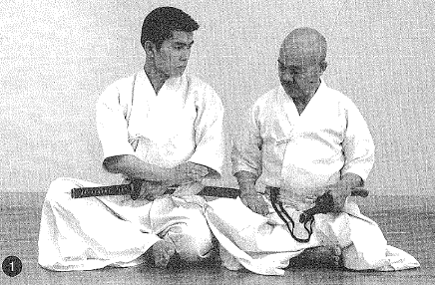

- You place your left hand on the koiguchi

- You place your right hand at your right hip

- Then you quietly stand up (maintaining your gaze on the enemy with eyes half closed, see. (2)

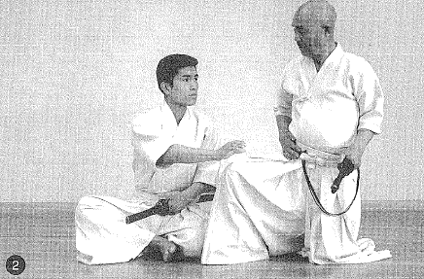

- Open your stance by stepping your left foot out to the left

- SimuItaneously, sweep your sword around from the downward position up to the left and open it out to the left, thereby breaking your enemy's grip on it. (3)

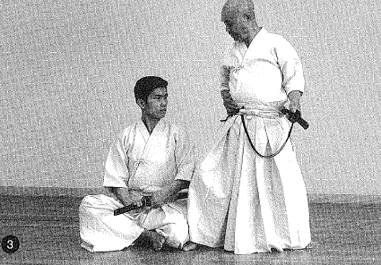

3. Slide your left foot around to the front as if to draw a half circle.

- Bring it around to the outside of the right foot and flex the toes backward, testing on the ball of the foot

4. Bend both knees forward. (4)

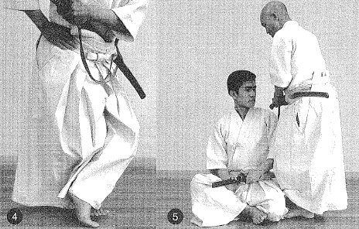

- Rest your right shin on your left calf (like a heron's legs)

- At the same time, take your sword which has been swept out to the right and sweep it quickly over the enemy's head and to your right. (5)

5. Grip the tsuka with your right hand.

- Draw the sword out to the right side (simultaneously pulling the saya back with the left hand)

- As you twist your body way around to the left so that your chest faces to the left

- Draw the left "pulling" hand back at the same time as the kensen leaves the koiguchi

- Draw and cut the enemy's chest with your right arm

- Simultaneously turnover your left foot

- Turning over the left foot means to place your left foot on the floor on its edge, with the inner arch of the foot turned up (6)

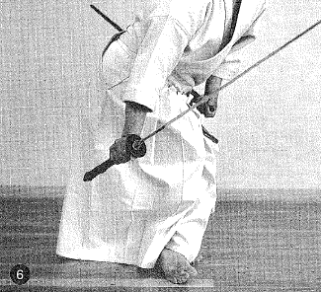

- When performing nukitsuke, the right fist comes just below the right hip with the blade angled diagonally in a downward slant.

- The parting of the kensen from the koiguchi should occur instantaneously as one would snap open a folding fan.

6. Turn the edge of the left foot up.

- SimuItaneously place your left hand on the spine of the blade at the monouchi (without moving the sword from the position of ending the nukitsuke) (7)

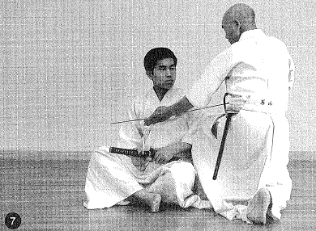

- Draw your right foot far back

- Extend your left hand straight out in front

- Turning your upper body to the right, knock the enemy down to the right (8)

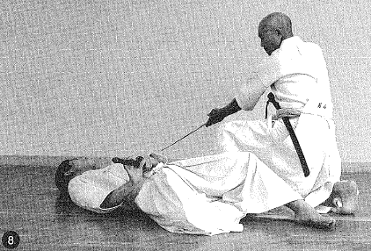

- When placing your hand on the spine of the sword, place it between your thumb and middle finger.

- To knock the enemy down, turn your upper body to the right while raising your right fist upward and (without moving the positioning of your left hand on the sword) use the left hand to push the kensen downward, bringing it through in a carving motion.

- Having completed this motion, the kensen should extended 25-30 cm past the left foot. At this time, relax the right elbow slightly and extend the left elbow. The right list should be at about the same height as the right shoulder with the blade of the sword pointing outward to the right. The tsuka is up, the kensen downward.

7. Take the sword which cut down the enemy and. as if returning it in the same way, twist it from the right to the left bringing it around slightly in front

- Bring the sword back up to a diagonal position above the right shoulder (9)

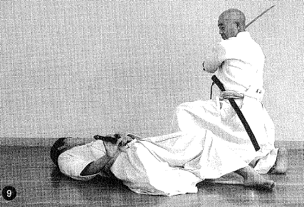

- At this point, extend the right hand upward at a right diagonal with the right fist slightly above the right shoulder; the blade of the sword should be flat, facing to the left and positional at a diagonal angle upward to the right, in line with the right hand. The kensen should be about 30 cm higher than level.

- Returning the blade to this position does not carry the meaning of hasso, it is done in order to facilitate the returning of the sword to jodan.

8. At the instant you draw your sword back to this position, drop your hips down so that your right kneecap is just behind your left heel.

- Turn your right foot to the left 90 degrees.

- Simultaneously bring your sword to jodun. (10)

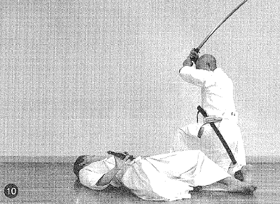

9. Then move your left foot amund another 90 degrees, then step your foot on the floor with a loud thud as if pinning the enemy's arm or the sleeve of his armor to the ground.

- Avoiding your own left knee, cut the torso of the enemy. (11)

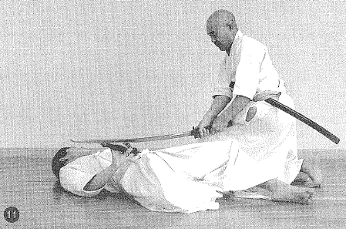

10. Perform chiburi and noto.

11. Then moving your left foot backward wound to the left, draw it in to your right inner thigh, facing the front to complete the form.

Gohonme Yamaoroshi Form #5 "Mountain Wind"

Intent:

- An enemy is sitting immediately to your right in tachihiza and facing in the some direction you are. He puts both hands on his tsuka with the intent of drawing his sword

- In response, you turn the hilt of your sword over and smack the enemy's hands with it. You then perform nukitsuke across the enemy's chest and cut him down. Finally, you execute kirioroshi through the enemy's torso.

Execution:

1. Putting the front to your right, sit in tachihiza in line with the enemy. (1)

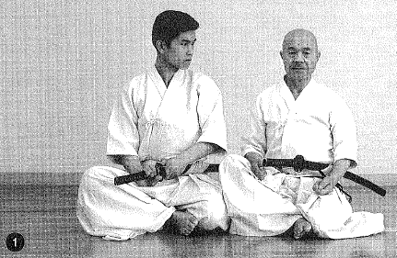

2. When the enemy places both hands on the tsuka

- Place your left thumb on the tsuba

- Place your right hand on your right hip

- Fix your gaze on the enemy

- Using your left knee as a pivot, turn to the right in order to face the enemy. (2)

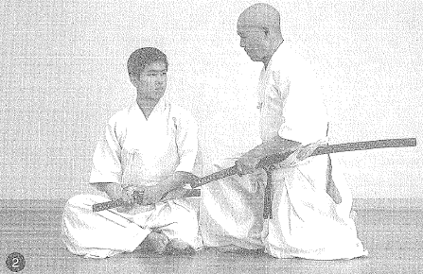

3. The enemy attempts to unsheathe his sword (literally, "cuts the koiguchi"), so you…

- Use your left hand to twist the saya to the left.

- Pull the sword forward with the blade facing downward. (3)

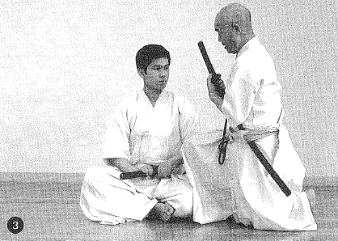

- Stomp your right foot out right on top of the enemy's left thigh with a resounding thud.

- Simultaneously, with your sword turned backwards, use the butt of your tsuka to rap the back of the enemy's fight hand sharply. (4) (5)

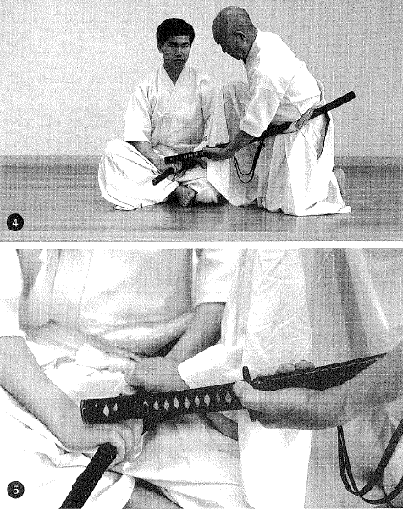

4. With your left fist gripping the tsuka, bring it up and around to the right side as if to pass the tip of your nose until the tsuba is at your right hip. (6) (Your right foot should be on top of your opponents left thigh)

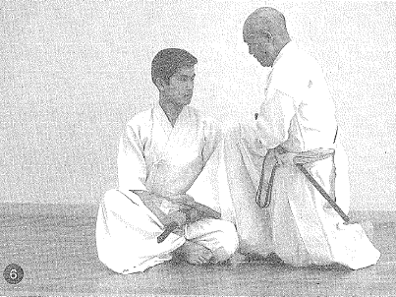

5. As you draw your sword, pulling the saya behind you to your left and the sword horizontally to the right. (7)

- Turn your hips sharply to the left

- Execute nukitsuke. Firmly pressing the sword across the enemy's right arm and chest

- Simultaneously pull back fully on your drawing hand (left hand). (8)

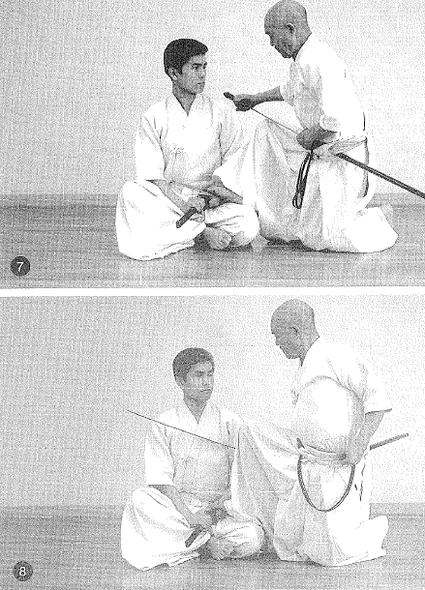

- Using your left knee as a pivot, sweep your left foot backward 90 degrees to your right heel.

- In doing this your right heel and left heel should line up and your tight list should be positioned just below your right hipbone.

- Am the instant of nukitsuke, your right foot should still be on top of the enemy's left thigh.

6. Place your left hand on the monouchi of your sword

7. Using your left knee as a pivot, sweep your left foot around 90 degrees to the left. (9)

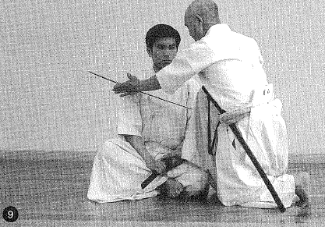

8. Then turning your entire body 90 degrees to face the right (using your left knee as a pivot again to sweep your left foot mound another 90 degrees), knock your enemy down to the right as if to carve through him. (10)

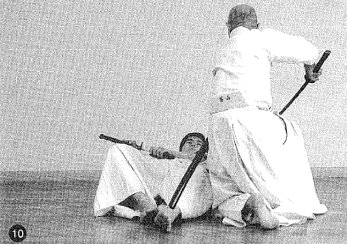

- At this instant, your foot chops from the enemy's thigh to the floor, pointing to the tent. The kneeling left leg should line up with the right leg in a parallel manner.

- At the instant you have finished knocking the enemy down, the kensen should be about 25 cm in from of the right toes.

9. As if to carry through with the motion, pull the sword up in an upward motion to the right. (11)

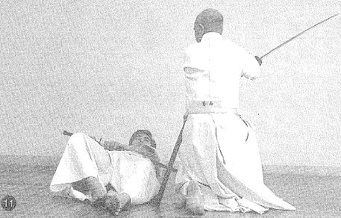

10. Having brought your sword up, step your right foot out one step toward the enemy's left arm with a resounding thud (your toes should point 90 degrees to the left)

- Adjust your body to face the left

- Perform furikamuri

- From jodan execute kirioroshi through the enemy's torso. (12)

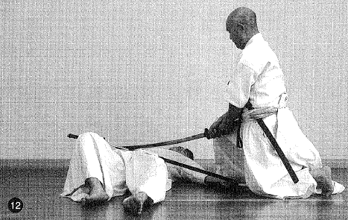

11. Remaining in this position, execute chiburi and noto.

12. Draw your right heel to your inner left thigh and end the form in a half crouching position.

Ropponme lwanami Form #6 "Waves Against the Cliff"

Intent:

- You thrust your sword through the chest or the solar plexus of an enemy who is sitting to your left.

- Then you knock the enemy down. performing kirioroshi to his back.

- There is the assumption that, feeling the ill intent of the enemy, you seize the opportunity and stab him in his right hip before he has commenced action. However, the scenario that Nakayama Sensei imagined is probably closer to the truth.

Execution:

1. Putting the front to your left, sit close to the enemy and facing in the same direction. (1)

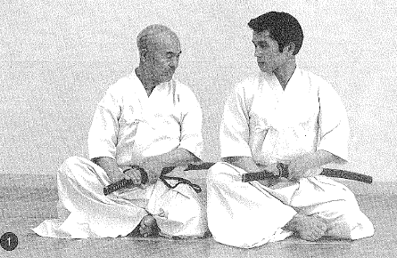

2. The enemy turns toward you, either trying to press down on your tsuka or to attack you (assumption)

- Draw your left foot far back while raising your hips up slightly (according to the circumstances, you might slide your left foot backwards slightly diagonally)

- Grip the tsuka with your right hand and without pulling it out in front, pull back hard on the saya until the kensen has completely cleared the koiguchi. (2)

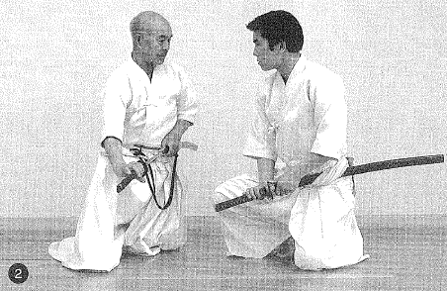

- Your eyes are fixed on the enemy.

This is a special characteristic of the Chuden forms. You must draw your sword without pulling the sword forward.

3. Al the instant the kensen leaves the koiguchi, your left knee touches the floor.

- Place the four fingers of your left hand on the back part of the kensen. (3)

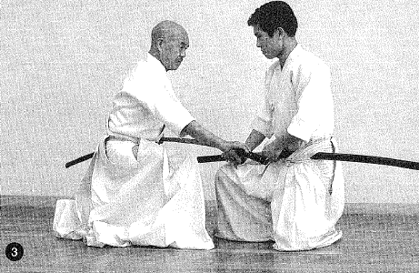

- Using your left knee as a pivot, turn 90 degrees to the left, directly facing the enemy.

- Draw your right foot to your left kneecap (your right foot will stick out about 1/2 step beyond your left kneecap)

- Simultaneously, taking the sword from the left in an upward direction (with your four left fingers remaining on the back of the kensen, wheel the sword mound so that the blade is facing downward)

- Draw the sword down to the outside of your right thigh, in a horizontal position (like the Japanese character, "one" (一) (4)

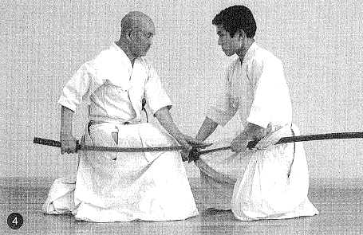

- Position your sword so that the blade is facing downward and parallel to the floor on the outside of your right thigh.

- Using your left thumb and middle finger as guides, place them on the spine of your sword at the kensen. The left hand should be either right to the side or right in front on the right knee.

4. Step your right foot out 1/2 step with a resounding thud.

- Simultaneously thrust your sword right through the enemy's solar plexus.
- Immediately pull your sword out of the enemy. (5)

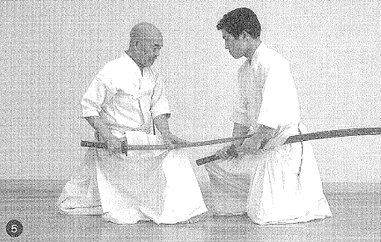

To perform the thrusting motion, fix your left hand above the right knee and thrust your right fist forward forcefully.

Also, when withdrawing your sword, keep your left hand fixed above your right knee and pull back fully with your right fist.

5. After withdrawing the sword, sweep it from the right to the left while maintaining the position of your left hand on the sword. (6)

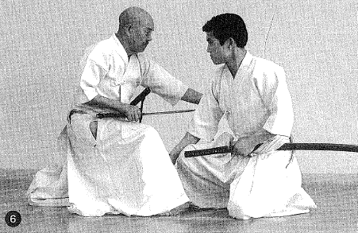

6. Place it against the enemy's back.

7. Draw it to your right, felling the enemy (7). (The felling of the enemy is the same as in the form, Yamaoroshi).

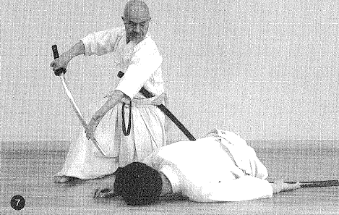

In executing the felling motion, your body turns 90 degrees to the right, using your left knee as the center. Both the right and left feet turn 90 degrees as well.

8. The enemy has fallen face down; step your right foot down onto the enemy's right arm with a resounding thud (with the right toes facing slightly to the left)

- Using your right toes as a pivot, mm 90 degrees to the left, so that you directly face the enemy

- Simultaneously, just as in the form Yamaoroshi, swing your sword back up to jodan. (8) (9)

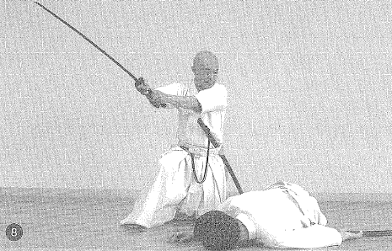

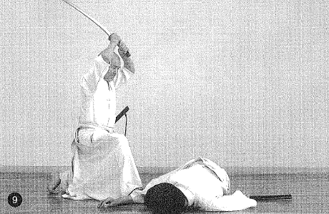

9. Execute kirioroshi through the enemy's back from jodan.

10. Maintaining this position, execute chiburi and noto.

11. Draw your right heel in to your left inner thigh and finish the form in a half crouching position.

Nanahonme Uroko Gaeshi Form #7 "Turning the Scales"

Intent:

- An enemy is sitting to your left, facing in the same direction. You draw your sword and cut him through the temple (or the neck).

- You perform kirioroshi from directly in from of the enemy. This is performed exactly as it is in the Shoden form Sato. The only difference is that Sato begins in seiza and this form, in keeping with Chuden begins in tachihiza.

Execution:

1. Putting the front to your left, sit in tachihiza. (1)

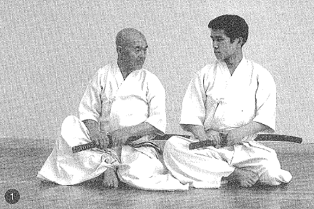

2. Using the ball of your right foot as a pivot, rise into chugoshi, turning 90 degrees to the left.

- As you face the enemy
- Simultaneously draw your left foot back (or draw your body back enough to create room to cut)
- Maintaining chugoshi execute nukitsuke to the enemy's temple. (2)

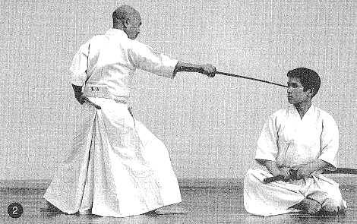

Begin to draw the sword as you are turning; when you have completed the turn, 2/3 of your sword should be drawn.

3. Draw your left knee to your right heel, placing it on the floor.

- SimultaneousIy execute furikamuri
- Step the right foot out one step
- Execute kirioroshi from directly in front on the enemy
- Perform chiburi and noto.

4. Draw your right foot to your left inner thigh and finish the form in a half crouching position.
Happonme Nami Gaeshi Form #8 "Returning Wave"

Intent:

- You spin around 180 degrees to your left, turning directly to the rear where the enemy sits facing in the same direction; execute nukitsuke to his temple.

- Then you execute kirioroshi from directly in front of the enemy, exactly as in the Shoden form Atarito. The only difference is that you begin the form in the Chuden tachihiza.

Execution:

1. Put the front to your back and sit in tachihiza.

2. As you draw your sword,

- Using the ball of your right foot as a pivot, turn 180 degrees to the left into chugoshi

- Spin around to face your enemy (your sword should be about 2/3 drawn)

- Draw your left foot fully back

- Maintaining chugoshi, execute nukitsuke to your enemy's temple

3. Draw your left knee to your right heel, touching it to the floor

- SimultaneousIy perform furikamuri

- Step your right fool out one step

- SimultaneousIy execute kirioroshi from directly in from of the enemy

4. Perform chiburi and noto (just as in form #7).

- Take care to keep the toes of your left foot pointing straight ahead and parallel to your right foot as you draw it back (do not let it assume an angular shape)

- Since the only difference this form has from the form Urokogaeshi is that you pivot I80 degrees instead of 90 degrees, refer to the illustrations in Urokogaeshi.

Kyuhonme Takiotoshi Form #9 "Down the Waterfall"

Intent:

- An enemy sitting directly behind you and facing in the same direction has grabbed your saya above the kojiri; you sweep the sword around so as to free his grip on it.

- You turn around and thrust your sword through the enemy's chest.

- As the enemy falls over, you execute kirioroshi from directly in from of him.

Execution:

1. Put the front to your back and sit in tachihiza. The assumption is that the enemy is sitting behind you facing your back, about 80 cm away. (1)

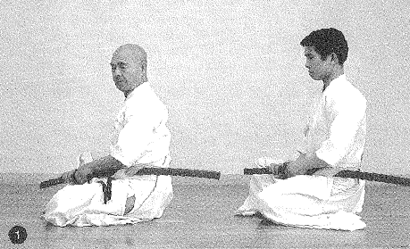

2. The enemy grabs your kojiri. (2)

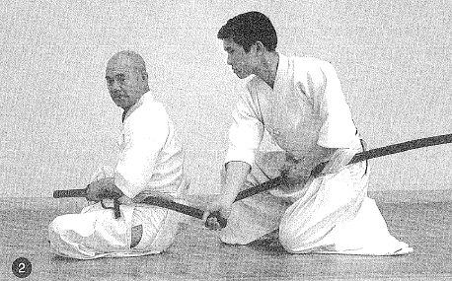

- Place your left thumb on the tsuba

- Place your right hand on your right hip and stand up (keeping your eyes on the enemy). (3)

- Step your left foot backward, assuming chugoshi, and turn 180 degrees. (4)

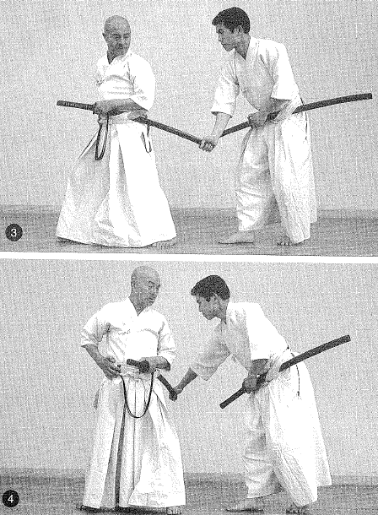

The front will be to the left of your body and you draw your saya upward to the right rear (the enemy is still holding onto the saya).

- At this point turn your left fist so that the five fingers point upward and jerk your tsuka from its downward position upwards in a sharp motion up to the level of your left breast as your left shoulder jerks to the left (first break away)

3. Take your left foot and move it around to the right with the toes pointed downward so that the left calf touches the right shin (hold like at heron's foot without letting the left foot touch the floor). (5)

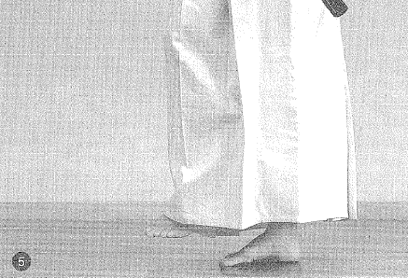

- At the same time, jerk the tsuka sharply upwards towards your left shoulder and in front of your left breast.

This is the second break away; twist your left fist to the right (6) (The blade is angled downward and is turned backwards; this releases the enemy's grip on the kojiri)

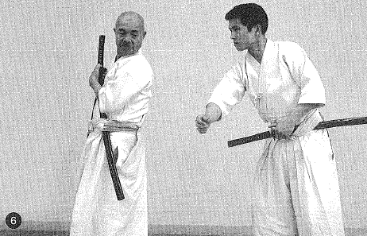

4. Place your right hand on the tsuka.

- Take the left foot which is still in the heron’s foot position and stomp it out to the right of the right foot with a resounding thud (the toes should point to the left)

- Simultaneously, step the right foot out to the right of the left foot about 30 cm away with a resounding thud

- Simultaneously, draw the sword to the right, slightly higher than horizontally (making full use of the drawing hand (left hand) . (7)

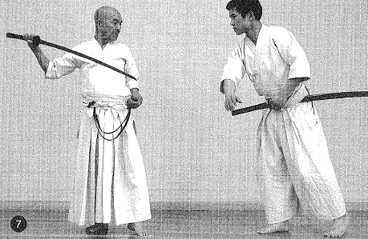

5. Take the left foot (which is opened out about 80 degrees to the left) and step it out one step

- Using your right heel as a pivot turn the right toes to face in the same direction as
the left toes (turning to the left to corner the
enemy)

- Thrust the sword into the enemy's chest in a downward motion. (8)

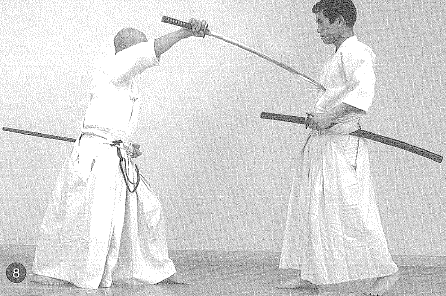

6. Execute furikamuri with a parrying motion.

- Step the right foot out one step
- Execute kirioroshi directly from in front of the enemy who is collapsing. (9)

7. Immediately perform chiburi from a kneeling position with the right knee up (10)

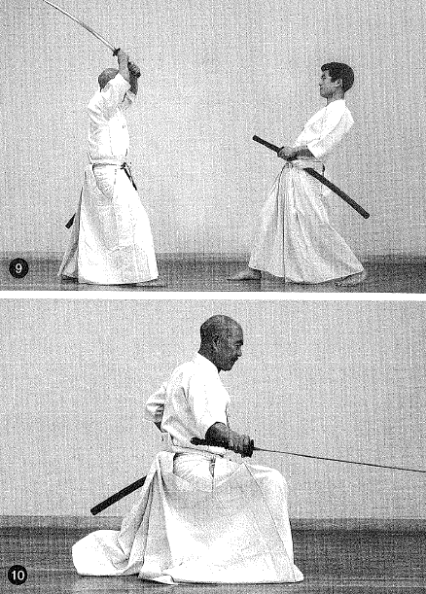

8. Perform noto.

Jupponme Nukiuchi Form #10 "Draw & Cut"

Intent:

- You are sitting in seiza facing an enemy who is close to you.

- Feeling the ill-intent of the enemy, you rapidly draw your sword and execute kirioroshi directly from in from of the enemy.

- This form carries the same intent as Nukiuchi in the Shoden; however, in Chuden, you must perform batto more rapidly than in Shoden.

Execution:

1. Sit in seiza facing the front.

2. Place the right hand on the tsuka and the left hand on the koiguchi.

3. When you have drawn both knees together

- Simultaneously, draw your sword in an upward direction on the left. (1)
- In one breath (without pause) perform furikamuri with ukenagashi. (2)
- Add the left hand to the tsuka. (3)
- With both hands immediately execute kirioroshi from directly in front of the enemy. (4)

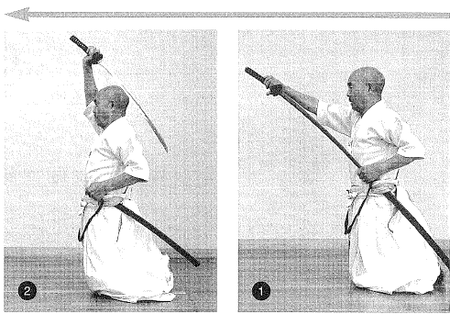

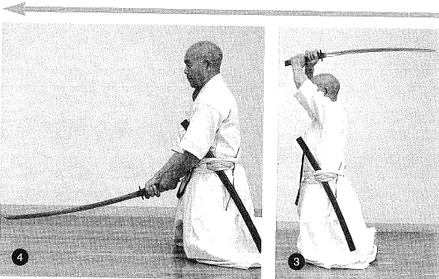

4. Execute chiburi and perform noto from the center of the blade. The rest conforms to the Shoden method.

Continuous Quick Draw

In Chuden tachihiza lai, there is a special method of practice where you perform all forms continuously without formally standing up and finishing each form. To do this, you end in a half-crouching position and immediately transition to the next form.

I have heard that this was a method devised by Oe Masamichi Sensei.

The term hayanuki (quick draw) does not only carry the meaning of drawing quickly. You must also perform each individual movement discreetly, observing the correct interval (timing) between movements.

Unless you are a master who has practiced Shoden and Chuden fully for over 10 years, you will not grasp the meaning of this method of practice. If you only try to draw quickly, your form will just deteriorate and will be ineffective. I therefore do not recommend this method for beginners but include it here for reference purposes.

Begin the first form facing the front and end the 10th form facing the front. In order to do this, change the order of the 6th and 7th forms and turn to the right in form #7, Uroko Gaeshi.

Order & Form

Order | Name | Beginning Direction | Ending Direction
1-3 | Form #1, 2, & 3 | Front | Front
4 | Form #4, Ukigumo | Front | Facing right of front
5 | Form #5, Yamaoroshi | Facing right of front | Facing rear of front
6 | Form #7, Urokogaeshi | Facing rear, turn right | Facing right of front
7 | Form #6, lwanami | Facing right of front | Front
8 | Form #8, Namigaeshi | Front | Facing rear of front
9 | Form #9, Takiotoshi | Facing rear of front | Front
10 | Forrn #10, Nukiuchi | Front | Front

For the quick draw to the right, there is a method of performing at one-handed quick draw; however, this is more difficult than performing a two-handed quick draw, so I will abbreviate my explanation.

There are instances when quick draw is performed at Taikai (tournaments); however, this is simply for your own personal practice and is never done in formal embu (presentations).

